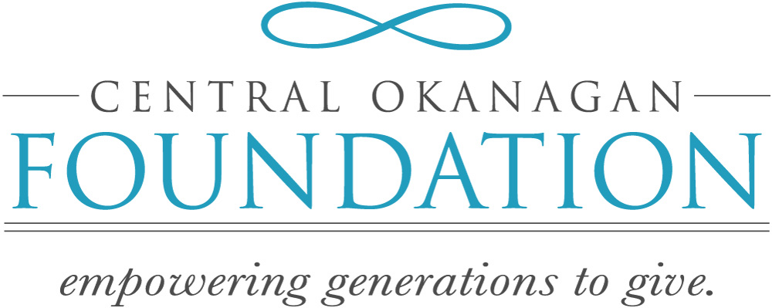

ENDOWED GIFT AGREEMENT

Initial Gift | _____________________ (the “Donors”) have provided a gift to establish an endowed fund within the Central Okanagan Foundation (the “COF”). The fund shall be known as the ____________________ (the “Fund”).
Gifts to the Fund | Each gift to the Fund (which, for greater certainty, includes the initial gift) or any property substituted for it, shall be held and invested by the COF in accordance with the Financial Management Policies of the COF in force from time to time.
Purposes | The purpose of this Fund will be to support charitable activities or charitable organizations whose activities are within the objects of the COF [and more specifically …].  The Donor(s) recognizes that a particular purpose or pattern of grants may not be achievable in the future; particularly if any of the named charitable organization(s) ceases to exist, winds down its operations or ceases to be a registered charity. Should this be the case, the COF shall make efforts to ensure that disbursements from the Fund are applied in support of other organizations carrying out similar purposes.
Distributions From the Fund | The COF shall determine the annual disbursements from the Fund in accordance with the Financial Management Policies of the COF in force from time to time. In years where current or accumulated income is not sufficient to meet disbursements, these amounts may be drawn from the capital of the Fund. If disbursements are less than current income, if applicable, the balance of current income shall be added to the Fund.  In the case of Flow-Through Funds, annual disbursements from the Fund shall be made in consultation with the Fundholder.
Recognition | All disbursements will be identified as coming from the Fund.
Administration Fee | The COF will charge the Fund an administration fee in accordance with the Financial Management Policies of the COF in force from time to time, provided that the COF shall only do so on a basis that is equitable relative to its other funds established with the COF.
Receipting | The COF will issue a charitable receipt for all donations to the fund according to the Income Tax Act and the COF’s receipting policies in effect from time to time.
Reporting to donors | The COF will provide a report on the financial status of the Fund on an annual basis.
Right to vary clause | This Agreement may be amended in the future in such respects as the COF and the Donor may mutually agree by written amending agreement.  Where reasonable attempts to contact the Donor have been made, the Board of the COF reserves the right to amend any of the terms of this Agreement governing the Fund in order to carry out the purpose of the Fund.  In no event shall any such amendment derogate from the following:  - The capital of the Fund and any additions to the Fund shall be held and invested in accordance with the Financial Management Policies of the COF in force from time to time; and  - The disbursements from the Fund shall only be used to support charitable activities or qualified donees (as defined by the Income Tax Act (Canada)) whose activities are within the objects of the COF.
Provision if fund doesn’t reach certain level – reverts to unrestricted | Until the total of gifts contributed into the Fund shall reach the minimum fund threshold, disbursements will be in accordance with the Fund Policies of the COF in force from time to time.  On the fifth anniversary of the date of this Agreement, if the total of gifts contributed into the Fund shall be less than minimum fund threshold required, then the Fund shall be held on an unrestricted basis, in accordance with the Fund Policies of the COF in force from time to time.

Fund Specific Clauses: choose appropriate clause(s) to include in Gift Agreement

Donor advised | Throughout the Donor’s lifetime, the COF shall seek the Donor’s advice with respect to the recipients for disbursements from the Fund, provided that the Donor is able and willing to advise. The Donor understands the COF’s Board has final authority regarding the recipients for disbursements from the Fund. The Donor understands that disbursements from the Fund can only be applied to support charitable activities of the COF or qualified donees under the Income Tax Act (Canada) whose purposes are consistent with the objects of the COF.  In any year when no such advice is received by the COF, or when there are no Donor-Advisor(s), or if such advice is received but not acceptable to the COF’s Directors, distribution of the annual disbursements will be made at the discretion of the COF Directors with consideration being given to the original intent of the Donor-Advisor(s) and by guided by the pattern of giving established for the Fund.
Successor Advisor | At such time as the Donor dies or becomes incapable of managing his/her affairs or advises the COF in writing that he/she no longer wishes to act as the advisor the successor shall be: __________________. The COF shall seek and receive the advice of the successor under the same terms as the Donor.  [Note: This provision is optional. It is also possible to include a clause stipulating that the COF shall make decisions regarding the disbursement of funds at its sole discretion, having regard to the original intent of the Donor.]
Field of Interest | The purpose of this Fund will be to support charitable purposes and activities of the COF and qualified donees whose purposes are consistent with the objects of the COF and, in particular  ,…i.e. to support research in the field of cancer.
Scholarships | The purpose of this Fund will be to support charitable purposes and activities of the COF and of qualified donees whose purposes are consistent with the objects of the COF and, in particular, to provide a scholarship or bursary for …  All scholarship amounts shall be paid to qualified donees for the benefit of the scholarship recipient.  Optional  The recipient(s) shall be determined on an annual basis. In the event that no suitable candidate is found in a given year, any earnings on the Fund not disbursed shall be added to the balance of the Fund.
Designated | The purpose of this Fund will be to support charitable purposes and activities of the COF and qualified donees whose purposes are consistent with the objects of the COF and, in particular, to support the programs and services of XYZ Charity.
Unrestricted | The purpose of this Fund will be to support the charitable purposes and activities of the COF, and to support the charitable activities of qualified donees whose charitable purposes are consistent with the objects of the COF.

IN WITNESS WHEREOF the Donor and the COF have executed the Agreement as of the ___ day of ______________, 20___.

Donor(s:

______________________________ _____________________________
Signature Signature

Donor Name: _________________________ Donor Name:________________________
Street Address:_________________________ Street Address:_______________________
City, Prov, ____________________________ City, Prov, ___________________________
Postal Code: __________________________ Postal Code: ________________________
Home Phone: _________________________ Home Phone:________________________
Cell Phone: _________________________ Cell Phone:__________________________
Email: _______________________________ Email:______________________________

CENTRAL OKANAGAN FOUNDATION:
Per: Authorized Signatory: Per: Authorized Signatory:
Name: ___________________________ Name: ____________________________
_________________________________ _________________________________
Signature Signature

