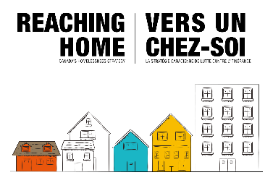


Declaration
Must be signed by as many people as required by the organization’s statutes or by-laws.
- I declare that I am legally authorized to sign and submit this Application on behalf of the Organization named in Section 1.
- I declare that the information provided in this Application and supporting documentation is true, accurate, and complete to the best of my knowledge.

Signatory Name (please print) | Title (please print) | Signature | Date(yyyy-mm-dd)
Signatory Name (please print) | Title (please print) | Signature | Date (yyyy-mm-dd)

