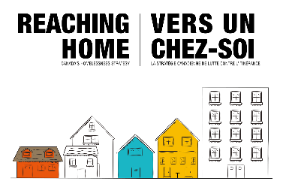

PARTNERSHIP TEMPLATE
Partnerships:
Contributing partners can include provincial and local governments, health authorities, not-for-profit organizations, and private foundations or corporations.
Please list all program specific partnerships below. Partners provide cash or in-kind contributions from sources other than Reaching Home funding.

 | TITLE OF PARTNERING ORGANIZATION and CONTACT PERSON NAME and CONTACT DETAILS | DOLLAR AMOUNT and INDICATE CASH or  IN- KIND CONTRIBUTION | LIST THE SERVICES OR ACTIVITIES BEING CONTRIBUTED THROUGH NON-REACHING HOME SOURCES
1 | NAME  EMAIL  PHONE NUMBER | CASH AMOUNT = $0.00  IN-KIND AMOUNT = $10,000.00 | Housing – 10x housing unit rentals for 12x months
2
3
4
5
6

