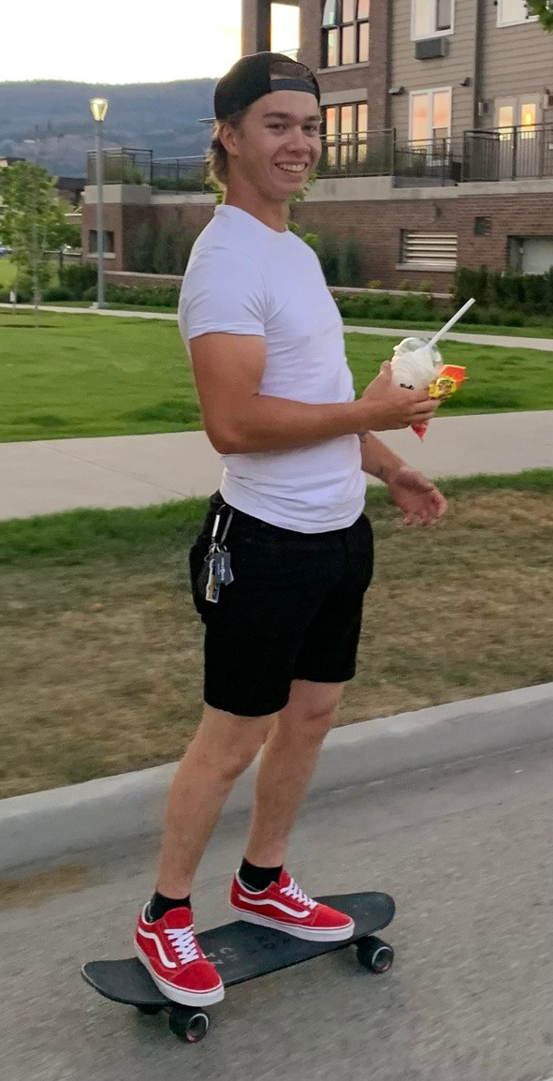


THE CAILEN
VILNESS
ANGEL ART FOUNDATION

Dear Applicant,

We would like to introduce you to a young man who lived his life with a smile on his face, his best foot forward, as well as his heart.

Cailen grew up in Kitimat BC, surrounded by a loving blended family. Grandparents, uncles, cousins, his mom, dad, stepmom, brothers, sisters, a niece and nephew he adored, as well as many friends. Cailen enjoyed fishing, camping, biking, and anything to do with the outdoors.

At an early age, Cailen showed a strong talent for sketching. He later designed his own tattoos. His father Chris said “He wanted to build things and be creative through his work.” Cailen moved to Kelowna and enrolled at the Center of Arts & Technology. He then switched careers, to be a tradesman.

Anyone who knew Cailen was drawn to his pure heart, integrity, work ethic, and complete kindness. Cailen was a man of faith, you could not have met a better young man.

On July 12/2021, Cailen put on his new steel toed boots, a crisp white shirt, kissed my daughter Jaydean and hugged his golden retriever Ellie, goodbye. He left proudly for work, to go dismantle the crane on the Brooklyn Tower on Bernard Avenue, Kelowna BC.

That devastating morning, we lost our Cailen and four other men. The emotional torture and hardships caused to the workers, families, emergency crew and anyone involved has caused such heartache. It is time to heal.

Cailen was accepted into his first year of carpentry just two days before he passed, which was his dream, he was only 23years young.

So, within the spirit of Cailen, he put his best foot forward as well as his heart. We would like to give back and are offering you an opportunity to walk forward into your goals and dreams.

The Cailen Vilness Angel Art Foundation will be given annually to one male recipient, entering their second year or beyond in the field of Fine Arts or Carpentry.

Tell us about yourself and why you feel you would be someone deserving of this gift. You will have our support and an angel by your side, smiling.
Best of Luck, Cherie

Cherie Rousson, Founder along with;
Chris Vilness, Honorary Chair & Erika Braham, Secretary and:
Connor, Corsen, Jaydean and Alanna Braham.
Danielle, Hayley, and Family are all Honorary Members of The Cailen Vilness Angel Art Foundation.

Application Deadline: May 4, 2026
One, $5,000 scholarship will be awarded

Eligibility:
Student must be:
Resident of British Columbia
Male entering their first, second, third or fourth year in the Field of Fine Arts OR Carpentry (any year)
Attending either Okanagan College or UBC Okanagan
Applicant must use the funds within 1 year of receipt of approval of the scholarship Scholarship funds will be sent directly to the accredited post-secondary institution

Please note: Canada Revenue Agency lists accredited post-secondary institutions as charities. To check if your post-secondary institution is eligible, please click here.

Along with answering the questions below, please include:
Letter of recommendation from either a teacher or personal reference

Application Process: Please email an electronic copy of application in Word or PDF format to:
abbie@centralokanaganfoundation.org

Notification: Successful applicants to this scholarship will be notified in early July.

Date (m/d/yr): Name:
Email address: Phone number: Address:
City & Province: Postal Code:

- Tell us about yourself. (max 200 words).
- Briefly summarize your post-secondary accomplishments in fine arts, carpentry and or/ academics. (max 300 words)
- How would receiving the Cailen Vilness Angel Art Foundation Scholarship make a difference for you? (max 300 words)
- What are your academic and professional goals? (max 300 words)
- Tell us about a situation in which you demonstrated integrity in your academic, personal or community life. How did your integrity guide your actions and what impact did it have on those involved? (max 500 words)

Please provide the details of your post-secondary education for the upcoming school year: Educational Institution Name
Program Name Year of study (1-4)

